[1]

This will contain the Title of the EDAI Project 16 font, Times New Roman in bold with single spacing

This will contain names of the members FY EDAI project group starting with name of the guide **without** any prefix like Prof. / Dr. / Sir / Madam / Mr. / Mrs. / Ms. / Sou. etc. followed by the Group Leader, AGL and next members in this format ---- for e.g. Sunil M. Patil, Radhika K. Sharma, K.V. Ramkumar ….. (14 font, Times New Roman, single spacing.)

Department of Engineering, Sciences and Humanities (DESH)

*Abstract* —Recently **Gesture controlled Laptops or computers** are getting very famous. This technique is called [Leap motion](https://www.theverge.com/2013/9/19/4745964/hp-envy-17-leap-motion-se-notebook) which enables us to control certain functions on our computer/Laptop by simply waving our hand in front of it. It is very cool and fun to do it, but these laptops are really priced very high. So in this project let us try building our own **Gesture control** Laptop/Computer by combining the Power of Arduino and Python.

We will use two Ultrasonic sensors to determine the position of our hand and control a media player (VLC) based on the position.

INTRODUCTION

Human Machine Interface or HMI is a system comprising of hardware and software that helps in communication and exchange of information between the user (human operator) and the machine.

We normally use LED Indicators, Switches, Touch Screens and LCD Displays as a part of HMI devices. Another way to communicate with machines like Robots or Computers is with the help of Hand Gestures.

Instead of using a keyboard, mouse or joystick, we can use our hand gestures to control certain functions of a computer like play/pause a video, move left/right in a photo slide show, scroll up/down in a web page and many more

In this project, we have implemented a simple Arduino based hand gesture control where you can control few functions of your web browser like switching between tabs, scrolling up and down in web pages, shift between tasks (applications), play or pause a video and increase or decrease the volume (in VLC Player) with the help of hand gestures.

# Literature Review

* The components are here and Arduino coding is done.
* Now we are working with the python code.

# Methodology/Experimental

* + **Components Required**
* Arduino UNO x 1
* Ultrasonic Sensors x 2
* USB Cable (for Arduino)
* Jumper wires
* Arduino compiler and python interpreter
* A Laptop with internet connection

## **Design**

* The design of the circuit is very simple, but the setup of the components is very important. The Trigger and Echo Pins of the first Ultrasonic Sensor (that is placed on the left of the screen) are connected to Pins 11 and 10 of the Arduino. For the second Ultrasonic Sensor, the Trigger and Echo Pins are connected to Pins 6 and 5 of the Arduino.
* Now, coming to the placement of the Sensors, place both the Ultrasonic Sensors on top of the Laptop screen, one at the left end and the other at right. You can use double sided tape to hold the sensors onto the screen.
* Coming to Arduino, place it on the back of the laptop screen. Connect the wires from Arduino to Trigger and Echo Pins of the individual sensors. Now, we are ready for programming the Arduino.

## Characterization/Pseudo Code/ Testing

Gljkdgji dfgjidfp pgjpjk ghpojkfhp pfghp piojgh lijghopoj lifjghij lijfghoij lkgjhoidjfgh ldigjolijdgh lkjndghojd lkjghlkjh lkjhjkhg

# Results and Discussions

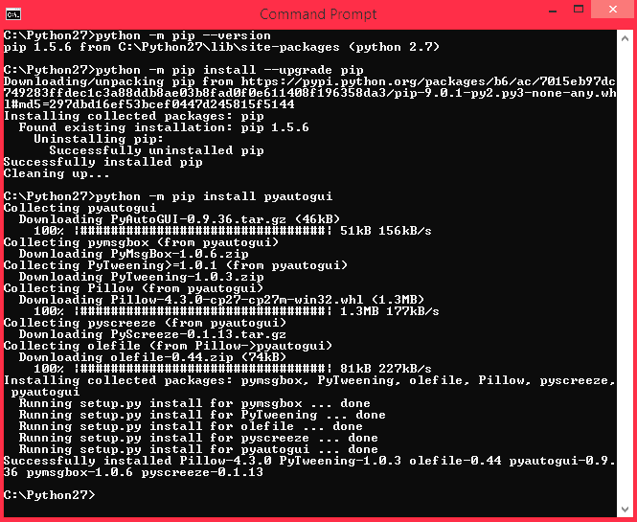

Figures

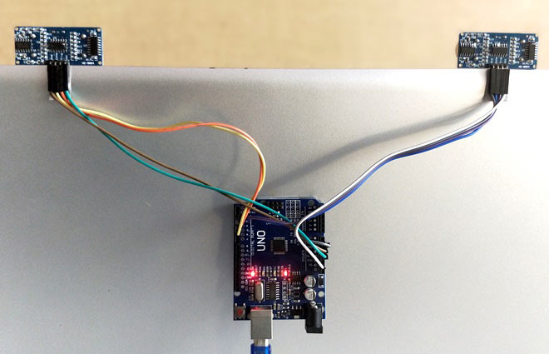

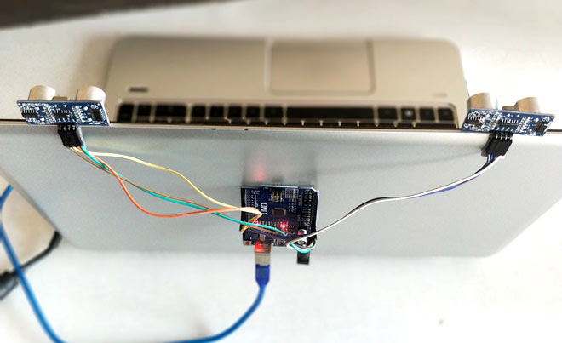

## Electronic Image Files (Optional)

Circuit diagram

[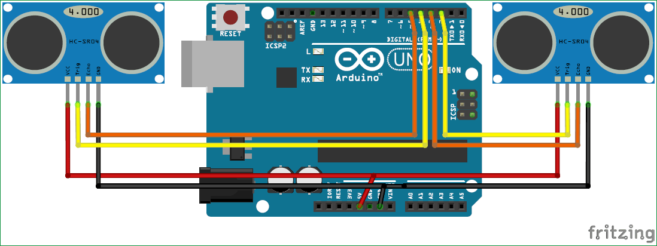](https://circuitdigest.com/fullimage?i=circuitdiagram_mic/Control-your-Computer-with-Hand-Gestures-using-Arduino-circuit.png)

.

# Limitations

‘skfl’m, jk ;tjkd ;ljkth ;lk;okh ;lkghlk ‘lsdfnm ;’lm, ‘;lgth ‘skfl’m, ljkth ;lk;okh ;lkghlk ‘lsdfnm ;’lm, ‘;lgth ‘skfl’m,

ljkth ;lk;okh ;lkghlk ‘lsdfnm ;’lm, ‘;lgth ‘skfl’m, ljkth ;lk;okh ;lkghlk ‘lsdfnm ;’lm, ‘;lgth ‘skfl’m, ljkth ;lk;okh ;lkghlk ‘lsdfnm ;’lm, ‘;lgth ‘skfl’m, ljkth ;lk;okh ;lkghlk ‘lsdfnm ;’lm, ‘;lgth ‘skfl’m,

# Future Scope

* **Medical Applications –**Advanced robotics systems with gesture recognition can be placed in hospitals or homes to recognize and treat life threatening conditions like heart attacks or strokes.
* **Alternative computer interfaces –** Gesture recognition, along with voice recognition, facial recognition, lip movement recognition and eye tracking combined can be used to create something called a perceptual user interface (PUI), a completely different way to interact with computer systems which will improve usability and creativity by leaps and bounds.
* **Entertainment applications –** Most videogames today are played either on game consoles, arcade units or PCs, and all require a combination of input devices. Gesture recognition can be used to truly immerse a players in the game world like never before.
* **Automation systems –** In homes, offices, transport vehicles and more, gesture recognition can be incorporated to greatly increase usability and reduce the resources necessary to create primary or secondary input systems like remote controls, car entertainment systems with buttons or similar.
* **An easier life for the disabled –** One of the biggest challenges faced today is providing separate and equally non cumbersome services to the differently abled and handicapped. While there are special provisions around the world, there’s still huge room for improvement to bring all lives on equal footing. Gesture recognition technology can eliminate a lot of manual labor and make life much easier for those who aren’t as fortunate as most of us are.

# Conclusion

Although a conclusion may review the main points of the paper, do not replicate the abstract as the conclusion. A conclusion might elaborate on the importance of the work or suggest applications and extensions.

Appendix

Appendixes, if needed, appear before the acknowledg-ment. For e.g. reference charts, graphs, tables, data sheets, manuals, brochures etc.

Acknowledgment

The preferred spelling of the word “acknowledgment” in American English is without an “e” after the “g.” Use the singular heading even if you have many acknowledgments. Avoid expressions such as “One of us (S.B.A.) would like to thank .” Instead, write “F. A. Author thanks ..” **Sponsor and financial support acknowledgments are placed in the unnumbered footnote on the first page**.

References

1.